15.11: Reading from the graph, a) 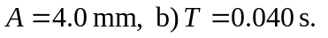 c) A displacement of 0.090 m corresponds to a time interval of 0.025 s; that is, the part of the wave represented by the point where the red curve crosses the origin corresponds to the point where the blue curve crosses the t-axis 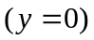 at 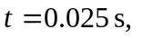and in this time the wave has traveled 0.090 m, and so the wave speed is 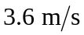 and the wavelength is 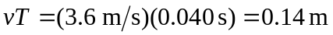. d) 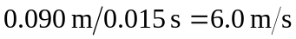 and the wavelength is 0.24 m. d) No; there could be many wavelengths between the places where 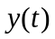 is measured.

